Winstedt - special needs school Singapore
The Winstedt School is one of the private schools in Singapore. In the article, we explain why special needs school Singapore is needed in the educational system in this country.

Schools in Singapore
The level of education in Singapore is considered very high, it is said to be the third best educational system in the world is based on the British system and puts a lot of emphasis on science. Moreover, children who are in school age to get to a public school must speak English in speaking and writing as well as in Chinese, Malay or Tamil. Pressure and competition among children is high. What absolutely is not conducive to the atmosphere in which young students can easily acquire knowledge and learn about themselves. Special needs school Singapore like Winstedt, is a private institution that was created for children who do not keep up with the science of material in traditional classes is also a place where they learn children with ADHD or dyslexia or other learning problems.
Special needs school Singapore - Is it worth choosing?

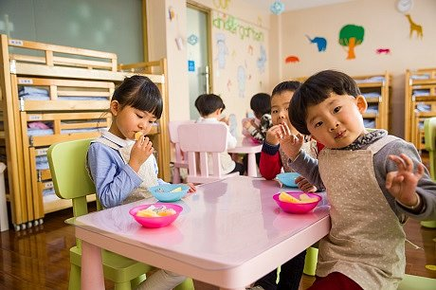
If you are wondering whether for your child, a good choice will be a school with a special atmosphere, friendly to children who are distracted, have a learning or learning problem, learn at school or suffer from dyslexia or ADHD, our answer is - it's worth it. Why? Because in special needs school Singapore classes are much smaller, and therefore, teachers have a physical opportunity to help children at the right time. Additionally, there is a psychologist and various methods to teach them in their own way.

