**The Winstedt - individual education school Singapore**

**Why individual education school Singapore it is sometimes a better choice than a public school. Check it in our article.**

**Education - private or public?**

Singapore has one of the best education systems in the world. It is assumed that the educational system in Singapore educational institutions ranks third in the whole world. This is definitely the perfect result! Education usually in public schools in Singapore is based on the British curriculum. The same applies to private schools, including international ones. Nevertheless, [**individual education school Singapore**](https://www.winstedt.edu.sg/) has several things, that can convince you, as a parent, to choose a private education system for your child.

**Individual education school Singapore - are they better?**

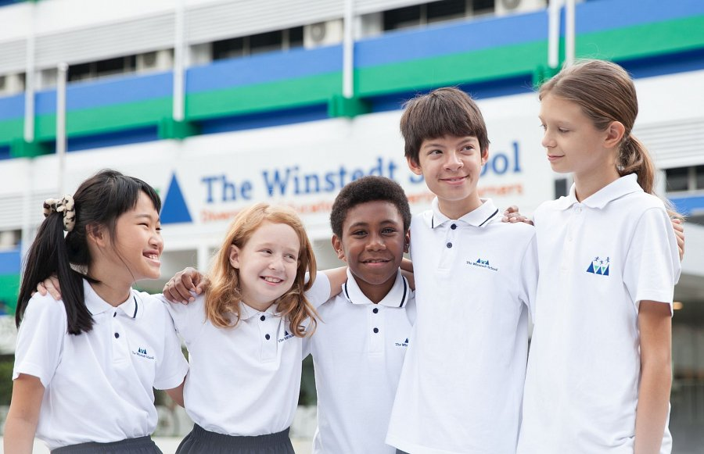

There are several things in public schools that can strongly interfere with many parents. The first matter, very controversial, is the acceptance of corporal punishment for little boys. Another thing - classes are very large, so the teacher will not even notice if the child does not keep up during the classes, you can forget about the individual approach to the child. What's more, children are assigned to Public Schools, in which there is a place. It means that the primary school may be located several kilometers from your place of residence. There are many different rules for **individual education school Singapore**. Do you want to check what? Check even the official website of The Winstedt School.