**The Winstedt - Individual Education Needs school Singapore**

**In this article, you'll read about how the Singapore education system works and find out why Individual Education Needs school Singapore is needed.**

**Singapure Education System**

How does the education system in Singapore work? Before answering this question, it is worth mentioning that education in Singapore is an extremely important area of life for every young person and his parents. We divide the system into State and private. In most schools on the British curriculum is a base, and certainly in those, that are public. A child to get to a public school must be able to speak and read in English. English is the language of instruction in schools, as the second children learn the official language,can choose from: Chinese (Mandarin), Malay or Tamil. The basis of science is the so-called STEM - science, technology, engineering, and mathematics. The level of teaching is very high and lowered for children. The Education System In Singapore, it is the third best in the world. If it is so good for what **Individual Education Needs school Singapore**?

**Winstedt individual Education Needs school Singapore**

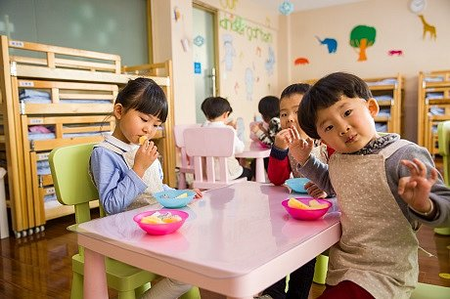

Unfortunately, such a huge pesja on the part of the system, causes that some children have different kinds of learning problems. [Individual Education Needs school Singapore](https://www.winstedt.edu.sg/) like Winstedt is a place where children learn methods that allow them to master the required information before the system but in their own time and in their own way. We are a school that understands that everyone learns in a different way.