**Winstedt- school for special education needs Singapore**

**Do you want to learn a little about education in Singapore? We'll explain it to you on the example of Winsted, which is a school for special education needs Singapore.**

**Education and schools in Singapore**

According to research carried out by independent institutions, it can be concluded that the Singapore Education System is the third of the best in the world. It is influenced by the fact that the British way of teaching was adopted in Singapore. And hence, in schools, English is the language in which a lesson is given to pupils. In addition, teachers strongly focus on the science of so-called science subjects. Considering how hard it is for schoolchildren to get into public schools (they must read and speak fluent English), a wide range of private schools has emerged, including The Winstedt [school for special education needs Singapor](https://www.winstedt.edu.sg/admissions)e.

**The Winsted School for special education needs Singapore**

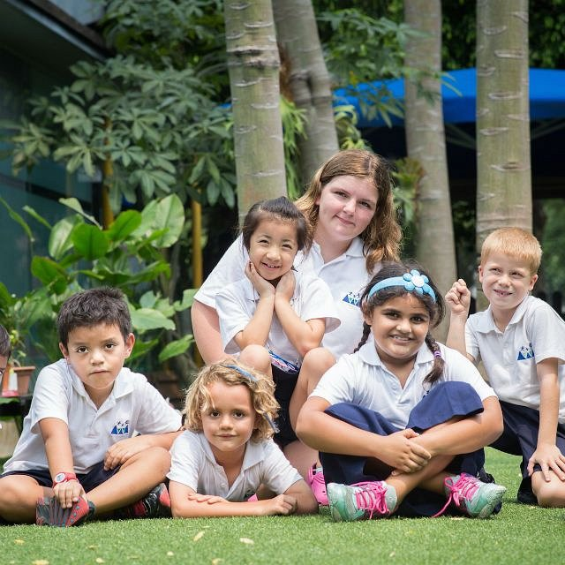

Winstedt school is a school for children from 4 to 16 years of age. We believe that each of them must find its own way to effective learning, which is why our classes are very small to facilitate this process. They consist of a maximum of 15 students with a teacher and his assistant. Classes run normally, from Monday to Friday, from 8:15 a.m to 3:30 p.m. We have 48 teaching faculty, for example, Information and Communication Technologies (ICT) or STEAM and 9 therapists and pastoral care, like Speech and Language Therapists, Clinical Psychologist and Behavioral Therapist. We are a small **school for special education needs Singapore** with current enrolment: 185 students.